The Liberty Church
2018 Scholarship Packet

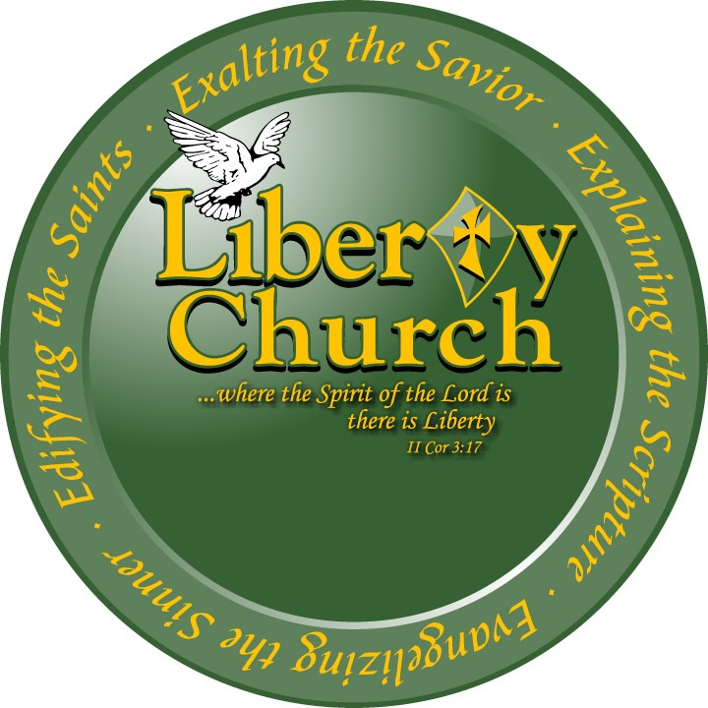

“We Love Freely”

“We Love Freely”

Dear High School Senior:

The Liberty Church is now accepting applications for the 2018 Academic Scholarship. This scholarship is awarded to deserving high school seniors who wish to further their education by earning a college degree. To be considered for this scholarship, students must meet the following guidelines and submit the following documentation:

____ Student must have at least a 2.75 Cumulative Grade Point Average

____ An “Official” school transcript w/seal must be submitted with the completed application

____ Two letters of recommendation (one from school personnel and one from someone in the community)

____ 500-word essay (Typed, 12 point font, Times New Roman, double-spaced) along with application

____ If you have applied and have been accepted to a two- or four-year college or university, please attach your acceptance letter with this application.

____ Official ACT/SAT scores (optional)

Completed application must be postmarked and submitted by Monday, April 30, 2018 to the following address:
The Liberty Church
Attn: Scholarship Committee
613 E. Street
Clarksville, TN 37042

Sincerely,

2018 Scholarship Committee

THE LIBERTY CHURCH
Scholarship Application

Name __________________________________________________________________

Address _________________________________________________________________

Phone # _______________________________Date of Birth _______________________

Parent (s) or Guardian _____________________________________________________

Name of High School _________________________________Current GPA ___________

College Choices:

1st Choice: _______________________________________________________________

2nd Choice: ______________________________________________________________

3rd Choice: _______________________________________________________________

Have you applied? _____ Have you been accepted? _____ (Attach a copy of acceptance letter)

Have you applied for financial assistance? _____ If yes, what type? _____________

___________________________________________________________________

___________________________________________________________________

List Extra-Curricular Activities and All Leadership Roles:

________________________________________________________________________

________________________________________________________________________

________________________________________________________________________

List Special Honors/Awards:

________________________________________________________________________

________________________________________________________________________

________________________________________________________________________

________________________________________________________________________

List All Community Service Involvement:

________________________________________________________________________

________________________________________________________________________

________________________________________________________________________

________________________________________________________________________

Discuss Your Career Goal (s):

________________________________________________________________________

________________________________________________________________________

________________________________________________________________________

________________________________________________________________________

I hereby certify that all of the aforementioned information is true and correct to the best of my knowledge. I also understand that any false statements may disqualify me from consideration for this scholarship.

Signed: _________________________________________________________________

Date: ____________________
Scholarship Essay Questions

Please select one of the two questions written below to write your essay. The essay should be: 500 words, typed, double-spaced, 12-point font, and Times New Roman format). Please utilize the principles of effective essay writing that include a focused main topic with supporting information. Also, be sure to check your essay for clarity, proper grammar, and correct spelling. Type, print and attach your essay to your application.

Question #1:

In what way is education important and how will this scholarship benefit you?

Question #2:

What obstacles/roadblocks have you faced in life, and how did you overcome them?

The Liberty Church Scholarship Scoring Sheet

Student Name: ________________________________________________________________

Total Points for Entire Student Portfolio = 100 Points

- Grade Point Average (up to 30 points)
- 2.75 – 2.8 a. 20.0 points________
- 2.8 -- 3.0 b. 25.0 points________
- 3.0 -- 3.5 c. 27.0 points________
- 3.5 and above d. 30.0 points________

Total:______________
- Letters of Recommendation (up to 20 points)
- Community Reference:
Recommended a. 1-5 points ________
Highly Recommended b. 6-10 points _______

- School Reference:
Recommended a. 1-5 points ________
Highly Recommended b. 6-10 points_______

Total:______________
- Essay (up to 30 points)
- 500 words in length a. 1-10 points _______
- Organization, transition and clarity b. 1-10 points_______
- Mechanics: spelling, structure, grammar c. 1-10 points _______

Total:______________
- Student Character (up to 10 points)
- Community Service a. 1-5 points_________
- Honors & Awards b. 1-5 points ________

Total:______________
- Extracurricular (up to 10 points)
- Leadership Roles a. 1-5 points_________
- Clubs, Activities, Sports b. 1-5 points_________

Total:______________

**Bonus Points**

ACT Score 23 and above 5 points __________

SAT Score 1140 and above 5 points __________

Overall Score (up to 100 points or 110 with bonus added) _________________________
Essay Rubric
Traits | 4 | 3 | 2 | 1
Focus & Details | There is one clear, well-focused topic. Main ideas are clear and are well supported by detailed and accurate information. | There is one clear, well-focused topic. Main ideas are clear but are not well supported by detailed information. | There is one topic. Main ideas are somewhat clear. | The topic and main ideas are not clear.
Organization | The introduction is inviting, states the main topic, and provides an overview of the paper. Information is relevant and presented in a logical order. The conclusion is strong. | The introduction states the main topic and provides an overview of the paper. A conclusion is included. | The introduction states the main topic. A conclusion is included. | There is no clear introduction, structure, or conclusion.
Voice | The author’s purpose of writing is very clear, and there is strong evidence of attention to audience. The author’s extensive knowledge and/or experience with the topic is/are evident. | The author’s purpose of writing is somewhat clear, and there is some evidence of attention to audience. The author’s knowledge and/or experience with the topic is/are evident. | The author’s purpose of writing is somewhat clear, and there is evidence of attention to audience. The author’s knowledge and/or experience with the topic is/are limited. | The author’s purpose of writing is unclear.
Word Choice | The author uses vivid words and phrases. The choice and placement of words seems accurate, natural, and not forced. | The author uses vivid words and phrases. The choice and placement of words are inaccurate at times and/or seems overdone. | The author uses words that communicate clearly, but the writing lacks variety. | The writer uses a limited vocabulary. Jargon or clichés may be present and detract from the meaning.
Sentence  Structure,  Grammar,  Mechanics, &  Spelling | All sentences are well constructed and have varied structure and length. The author makes no errors in grammar, mechanics, and/or spelling. | Most sentences are well constructed and have varied structure and length. The author makes a few errors in grammar, mechanics, and/or spelling, but they do not interfere with understanding. | Most sentences are well constructed, but they have similar structure and/or length. The author makes several errors in grammar, mechanics, and/or spelling that interfere with understanding. | Sentences sound awkward, are distractingly repetitive, or are difficult to understand. The author makes numerous errors in grammar, mechanics, and/or spelling that interfere with understanding.
Reviewer’s
Comments

Timeline for the Application Process

- Applications will be available Sunday, April 1, 2018.

- The deadline for all applications is Monday, April 30, 2018.

- The scholarship recipient winner will be announced Sunday, May 13, 2018.

- The recipient will deliver an acceptance speech ‘Scholastic Sunday’ May 20, 2018.

